Component Diagram

- Life Care Hospital is a renowned hospital that uses a simple hospital management system named Life Care hospital management. The XYZ hospital management component is dependent on the access of data from four components: Hospital, Patient, Doctor, and Nurse. These four components provide an interface named readData. There is another component named Appointment which provides two interfaces setAppointment and getAppointmentDetails. The Hospital, Patient and Doctor component implements the getAppointmentDetails interface while the Receptionist component implements the setAppointment interface. There are three more components named Synchronization, Database and Security. The dbConnector interface is provided by and required by Database and Synchronization components respectively. Both Security and Synchronization Components provide three crucial interfaces; accessControl, Encryption, and Decryption which are required by all of the components except XYZ hospital management and the Database component.
Now Design a component diagram based on the above scenario.

- WebStore sub-system contains three components related to online shopping - Search Engine, Shopping Cart, and Authentication. Search Engine component allows to search or browse items by exposing provided interface Product Search and uses required interface Search Inventory provided by Inventory component. The Shopping Cart component uses the Manage Orders interface provided by the Orders component during checkout. Authentication component allows customers to create an account, login, or logout and binds customers to some account.
Accounting subsystem provides two interfaces - Manage Orders and Manage Customers. Delegation connectors link these external contracts of the subsystem to the realization of the contracts by Orders and Customers components.
Warehouses subsystem provides two interfaces Search Inventory and Manage Inventory used by other subsystems and wired through dependencies.

Answer to 2 is given below. (Next page / Scroll down).

Answer to 2:

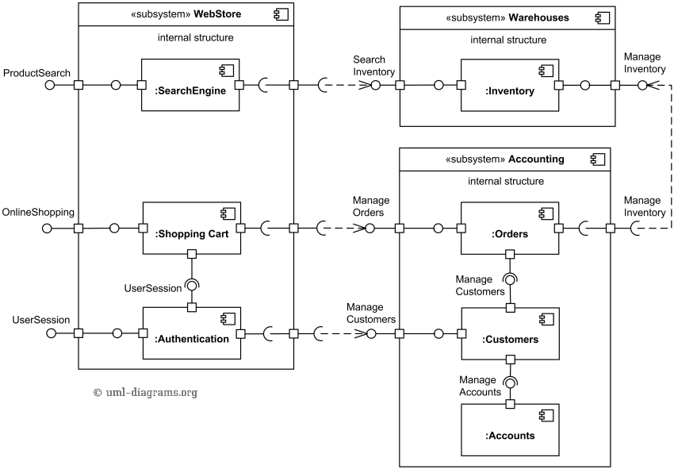

- An example of UML component diagram with some simplified view of provided and implemented components utilizing SafeNet Sentinel HASP Software Licensing Security Solution and Licensing API.
On the top of the diagram we have some software implemented using Sentinel HASP - License Status .Net application and License Services Java component. License Status application is intended to show license status and is manifested (implemented) by license_status.exe artifact. License Services Java component implements License Service interface and could be used by other Java applications or services.
License Status application uses License Services Net component through the License Service interface implemented by this component. The License Services Net component uses the HASP .Net API provided by the HASP .Net Runtime component which is part of the Sentinel HASP product.
License Services Java component uses HASP Java Native Interface Proxy to communicate with HASP Java Native Interface component, both components provided by Sentinel. When product is used in Microsoft Windows, the HASP Java Native Interface could be manifested by either HASPJava.dll (32 bit OS), HASPJava_x64.dll, or HASPJava_ia64.dll (64 bit OS).
The SafeNet Sentinel LDK 6.1 Licensing API includes:
structural declarations and information on individual Sentinel Licensing API functions,
description of XML tags that can be used to define scope and output format of various API functions,
description of all API return codes.
Sentinel LDK installation includes API samples for various programming languages including C, C#, Java. For example, HASP Java API includes 4 Java classes: Hasp, HaspApiVersion, HaspTime, and HaspStatus in Aladdin package. Those classes are bundled into HASPJava.jar artifact. The HASP Java API classes load and link native methods from a platform-specific native library using the System.loadLibrary() method. As we said, for Microsoft Windows the DLL library loaded is one of the HASPJava.dll, HASPJava_x64.dll, or HASPJava_ia64.dll.

Answer to 3 is given below. (Next page / Scroll down).

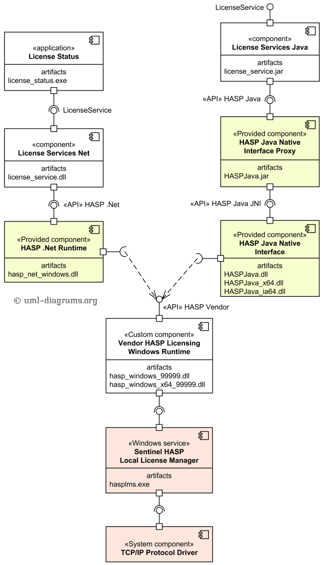
- For large distributed business franchises in Bangladesh, a well-known software farm is building software that can be used commonly. Here the concept is that the business management policies are provided from a Head office and the Back offices are the distributed franchisors who abide by the business policies.
Here, the Head Office component contains five components that are Stock Item database component, Policy component, Tax component, Rebate component, and Special Price component. The Policy component provides two interfaces, setPolicy, and taxExempt. The setPolicy interface is required by the Stock Item component. Tax and Rebate components provide an interface called readStock which is dependent on stock details from the Stock Items component. These two components also require the taxExempt interface. The Special Price component requires the tax price interface which is provided by the Tax component and Rebate component. The Tax component provides taxStatus interface, Rebate component provides rebateStatus interface, Special Price component provides specialValue interface which are exposed outside of The Head Office component through 3 ports and all three of these interfaces are required by The Back Office component. The Back Office component provides two interfaces taxExempt and setArea which are required by the Tax Rebate component and the Region Component respectively.
Design a Component Diagram based on the above scenario.

